Top of Form

Bottom of Form

**How to Lock (SU01) & Unlock (SU10) a SAP User**

**Locking a user**

The Purpose of locking user is to temporarily deactivate the users so that they cannot longer access the system.  
  
Users can be locked in 2 ways:-

* Automatically
* Explicitly/Forcefully

**Automatically: -** There are two possibilities when users get lock automatically

* Maximum number of failed attempts:- controlled via the parameter **login/fails_to_user_lock.** If a value is set to 3 it means after 3 failed attempts user will be locked.
* Auto unlock time: - "**login/failed_user_auto_unlock**" defines whether user locked due to unsuccessful logon attempts should be automatically removed at midnight.

**Explicitly/Forcefully:**We can lock and unlock users in 2 ways-

1. Lock single user (**SU01**)
2. Lock multiple user (**SU10**)

**Procedure to lock a single user**

**Step 1)** Execute T-code **SU01**

[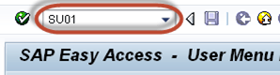](https://www.guru99.com/images/sap/2013/05/051413_0752_1.png)

**Step 2)** Enter a username in **User**field.

[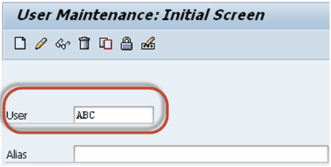](https://www.guru99.com/images/sap/2013/05/051413_0752_2.png)

**Step 3)** Press **Lock/Unlock** button

[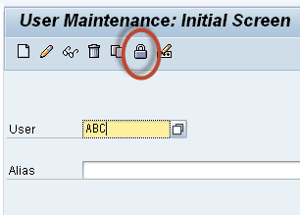](https://www.guru99.com/images/sap/2013/05/051413_0752_3.png)

**Step 4)** In the next screen, Press **Lock** button again to lock the user.

[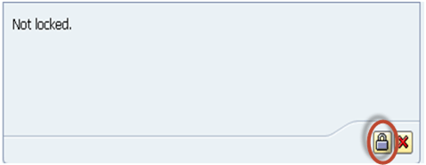](https://www.guru99.com/images/sap/2013/05/051413_0752_4.png)

**Procedure to lock multiple users**

**Step 1)** Execute T-code **SU10**

[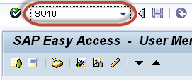](https://www.guru99.com/images/sap/2013/05/051413_0752_5.png)

**Step 2)** Enter users a username in **User**field.

[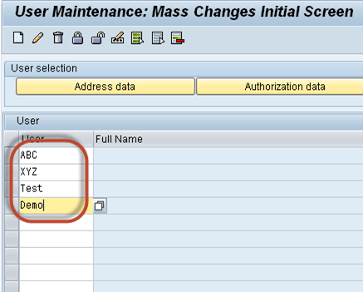](https://www.guru99.com/images/sap/2013/05/051413_0752_6.png)

**Step 3)** Press **Lock/Unlock** button

[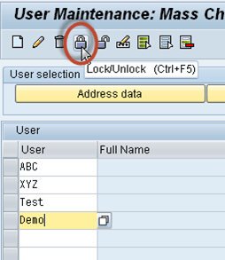](https://www.guru99.com/images/sap/2013/05/051413_0752_7.png)

All the users listed will be locked

**Procedure to unlock a user**

**Step 1)** Execute T-code **su01**

[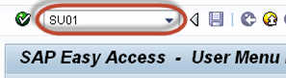](https://www.guru99.com/images/sap/2013/05/051413_0752_8.png)

**Step 2)** Enter username in **User**field.

[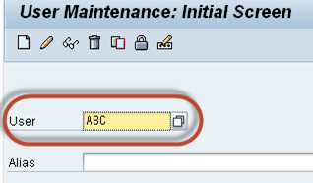](https://www.guru99.com/images/sap/2013/05/051413_0752_9.png)

**Step 3)** Press **Lock**/**Unlock** button

[](https://www.guru99.com/images/sap/2013/05/051413_0752_10.png)

**Step 4)** Press **Unlock** button

[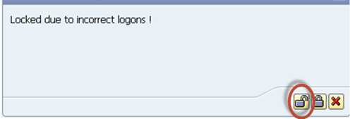](https://www.guru99.com/images/sap/2013/05/051413_0752_11.png)

**Procedure to unlock multiple users**

**Step 1)** Execute T-code **SU10**

[](https://www.guru99.com/images/sap/2013/05/051413_0752_12.png)

**Step 2)** Enter users' username in **User**field.

[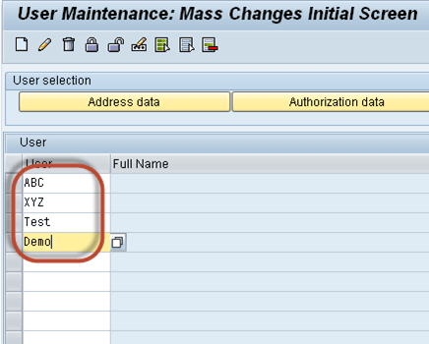](https://www.guru99.com/images/sap/2013/05/051413_0752_13.png)

**Step 3)** Press **Unlock** button

[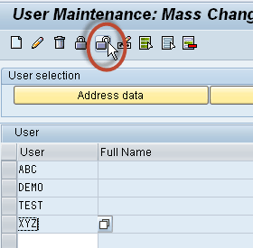](https://www.guru99.com/images/sap/2013/05/051413_0752_14.png)

Users will be unlocked